**Administrative**

**Today’s session**

Course introduction

File management

Object-oriented programming

Java introduction

Eclipse introduction

Notepad++

Java terms

**Session Topics**

**Course introduction**

● Course information

● Course schedule

**File management**

● File management is a key skill of the application developer.

● Storing files in an organized folder structure enables you to retrieve the files quicker.

● Here is one way to organize and manage files for this course:

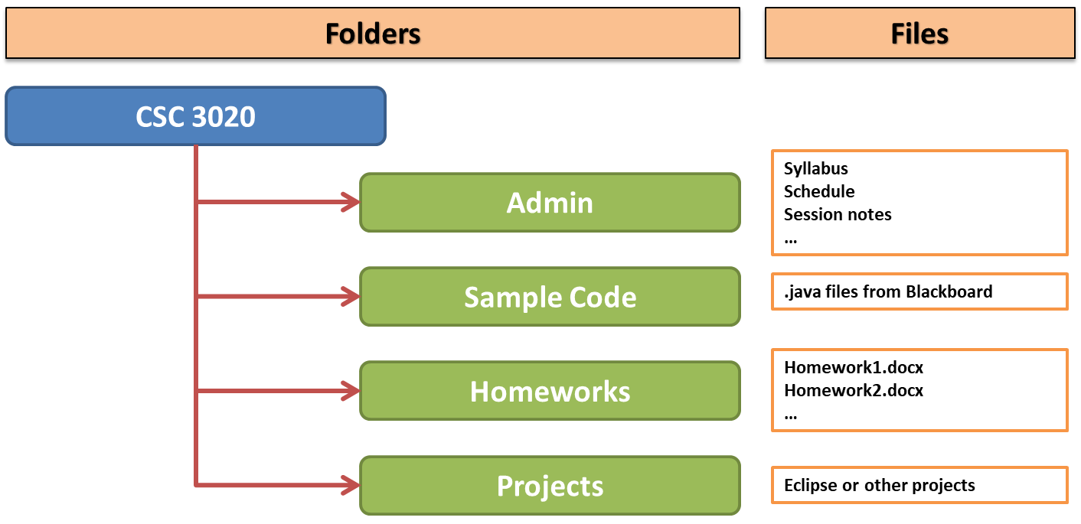

**Object-oriented programming**

● A **class** is a blueprint.

● An **object** is a *running* version/instance of something created from a class.

● A **field** is a value stored in an object.

● A **method** is an action that may be run on or within an object.

● Fields are typically invisible to the outside world while methods are typically visible.

**Java introduction**

● Java enables us to create object-oriented applications.

● The [TIOBE index](http://www.tiobe.com/tiobe_index/) shows the popularity of programming languages.

**Java Development Kit (JDK)**

● The JDK is a set of applications, libraries, and other files supporting the development of Java applications.

● The JDK is maintained by Oracle Corporation and runs on Linux, Mac OS X, Solaris, and Windows.

● The JDK includes the Java Runtime Environment (JRE) which is required to run Java software.

● The JRE consists of the Java Virtual Machine (JVM), Java platform core classes, and supporting Java platform libraries.

● The JDK is available at [www.oracle.com/technetwork/java/javase/downloads/index.html](http://www.oracle.com/technetwork/java/javase/downloads/index.html)

● To check which JDK version, if any, is installed on a Windows 10 computer:

1) Click **Start** button.

2) Select **Java / About Java**.

● To check for JDK updates on a Windows 10 computer:

1) Click **Start** button.

2) Select **Java / Check For Updates**.

● To check which JDK version Eclipse is using, click **Window / Preferences / Java / Compiler**

**Java Virtual Machine (JVM)**

● The JVM runs the Java application.

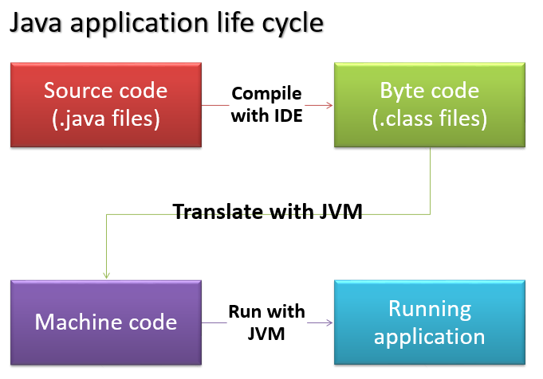

**Eclipse introduction**

● A primer on the use of Eclipse is available in document **Using Eclipse** on Blackboard.

**Notepad++**

● Notepad++ is an excellent text editor.

● Notepad++ may be used for managing (text-based) input and output files.

● Notepad++ is available at [notepad-plus-plus.org](https://notepad-plus-plus.org/).

**Java terms**

● Library

✓ A library is a set of one or more JAR files.

✓ A library may be a folder or a file.

✓ If the library is a file, it is bundled as a JAR file.

● Java Archive (JAR) file

✓ A JAR file is some combination of packages, classes, and other files.

✓ A JAR file has extension **.jar** and has a format similar to a **.zip** file.

✓ A JAR file may be read or created with JDK command **jar**

✓ A JAR file may be read or created within a Java development tool.

✓ A JAR file may created to be runnable.

● Package

✓ A package is a set of one more classes.

✓ A package name is made up of one or more parts (words) separated by periods.

✓ Each package name part corresponds to a folder on the computer.

✓ A package name is typically formed by starting with the most general part and ending with the most specific part: javax.swing.border

● Class

✓ A class is set of one more class members.

✓ A class is a file with extension **.class**

✓ The name of the class matches the name of the .class file containing it.

✓ The first statement of every .class file is **package** which indicates which package it is a part of.

✓ A class may access packages outside of its package using the **import** statement.

● Class member

✓ A class member may be a field (variable), method, or nested class.